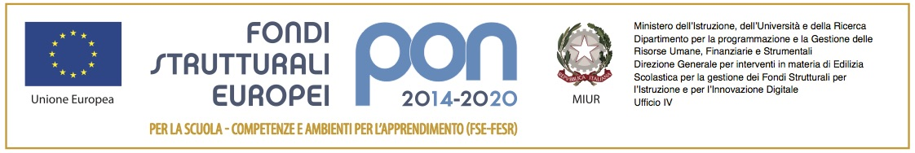
Prot.
AL DIRIGENTE SCOLASTICO

e p.c. AL DIRETTORE S.G.A.
MODULO RICHIESTA MATERIALE DA ACQUISTARE
(“Mi esprimo attraverso” - Codice 10.2.2A-FSEPON-SI-2017-161)
Sede

Il sottoscritto____________________________, Tutor del Progetto PON FSE “Imparo esplorando”-10.2.2A-FSEPON-SI-2017-161,. CUP H95B18000020007- Modulo :………………………………………
chiede a supporto delle attività didattiche e laboratoriali i seguenti materiali:
- N° ___ penne
- N° ___ quadernoni
- N° _____ ……………..
- __________________________________________________________________;
- __________________________________________________________________;
- __________________________________________________________________;
- __________________________________________________________________;
- __________________________________________________________________;
- __________________________________________________________________;
- __________________________________________________________________;
- __________________________________________________________________;
- __________________________________________________________________;
- __________________________________________________________________;
- __________________________________________________________________;
- __________________________________________________________________;
- __________________________________________________________________;
- __________________________________________________________________;
- __________________________________________________________________;
- __________________________________________________________________;
- __________________________________________________________________;
- __________________________________________________________________;
- __________________________________________________________________;
- __________________________________________________________________;

Canicattini Bagni, _______
Il Tutor
________________________
_________________________________________________________________________________________________

Vista la disponibilità economica prevista nel PON FSE: ,
- si autorizza l’acquisto;
- non si autorizza l’acquisto
- si autorizza parzialmente, fino all’ammontare

Il Direttore Servizi Generali Amministrativi Il Dirigente Scolastico
Rag. Salvatore CARRABINO Prof.ssa Alessandra SERVITO

